# B.Tech. Computer Engineering

DEVANG SHAH

devangvshah16@gmail.com

+91 9326059054

llinkedin.com/in/devang-shah-63a29b210

github.com/Devang-Shah-49

**EDUCATION**

Dwarkadas J. Sanghvi College of Engineering

*02/2021 - Present*,

*Achievements/Summary*

Currently studying in First Year at DJSCE, Mumbai (Autonomous college affiliated to University of Mumbai). Also, actively participating in various college events and contests to boost my skills.

# H.S.C.

SMPRS Junior College, Mulund

*06/2019 - 03/2020*,

*Achievements/Summary*

Successfully cleared Higher Secondary Certificate Exam under the Maharashtra State Board with an aggregate of 81.85%. Also cracked Competitive Entrance Examinations(JEE, CET, BITS) with flying colours.

# S.S.C.

## St. Xavier’s High School & Junior College, Powai

*06/2017 - 03/2018*,

*Achievements/Summary*

Bagged a good rank in Secondary School Certificate Exam under the Maharashtra State Board with an aggregate of 93.2%.

**ACHIEVEMENTS**

**#** Served as Red House team Leader in Secondary School for year 2015-16.

**#** Participated and achieved Olympiad medals for year 2016-17.

**#** Awarded with drawing certificate at City-level contest 2018.

**#** Certified from DJ Codestars + CodeChef for Code Uncode 4.0 held on 11th March, 2021.

**#** 2-Star Coder at Hackerrank.

**#** Awarded Prizes in various Drawing, Debate, Elocution, Quiz, and team events and contests.

## LANGUAGES

Java

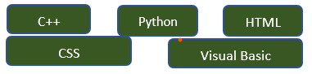

# SKILLS

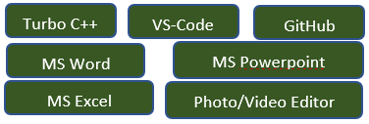

# ACTIVITIES

**#** Participating in C++ Workshop by DJ Codestars, 2021.

**#** Participated in Web & App Development Workshop at HackPrep, DJ Unicode 2021.

**#** Participated in Python Workshop and Codatron at Oculus SPIT, 2021.

**#** Participated in Cin/Cout & Code-Uncode 4.0 contests on Hackerrank ,2021.

**#** Participated in GitUp & Open-source Workshop by DJ IEEE Brainwaves, 2021.

# INTERESTS

Speech Telling Sports Dancing Reading

**CAREER OBJECTIVE**

To increase my academic knowledge and technical skills and be an expert in the domain through continuous learning, improvement and perseverance.

**REFERENCES**

Availabe upon requests